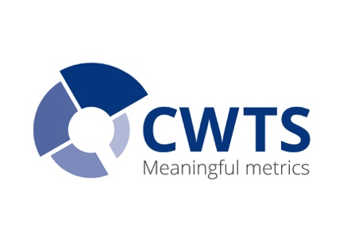 | Measuring Science and Research Performance  13-17 March 2017  CWTS, Willem Einthoven Building, room A2.03, Leiden

Monday 13 March: Introduction and Data Collection
09.00-09.30 Welcome, coffee/tea Atrium; Willem Einthoven Building (1st floor)

09.30-10.00 Inge van der Weijden Getting Acquainted
10.00-11.15 Paul Wouters Assessing Research Performance: Missions and Metrics

11.15-11.30 Coffee/tea break

11.30-12.00 Thed van Leeuwen Research Assessment in Practice
12.00-12.30 Inge van der Weijden Introduction to Group Assignments

12.30-13.30 Lunch break (Atrium)

13.30-14.30 Clara Calero Data Sources and Data Collection
14.30-16.30 Clara Calero Group Assignment: Data Sources and Data Collection
16.30-17.00 Tutors Plenary Discussion with tutors

18.00 Dinner at Kasual, Stationsweg 30, Leiden

Tuesday 14 March: Citation Analysis
09.00-10.30 Clara Calero Citation analysis: Rationale and Indicators (1)

10.45-11.00 Coffee/tea break

11.00-11.45 Clara Calero Citation analysis: Rationale and Indicators (2)
11.45-12.30 Ludo Waltman Journal Impact Indicators

12.30-13.30 Lunch break (Atrium)

13.30-14.00 Ludo Waltman Citation analysis: h-index
14:00-14:45 Clara Calero University rankings
14:45-16.30 Ludo Waltman & Clara Calero Group assignment: CWTS Monitor
16.30-17.00 Tutors Plenary Discussion with tutors

18.00 Dinner at Luxor, Stationsweg 19, Leiden

Wednesday 15 March: Bibliometric Network Analysis
09.00-11.00 Ed Noijons & Vincent Traag Bibliometric Network Analysis: Introduction

11.00-11.15 Coffee/tea break

11.15-12.30 Ed Noijons & Vincent Traag Hands-on Assignments VOSviewer

12.30-13.30 Lunch break (Atrium)

13.30-14.30 Clara Calero & Alfredo Yegros Bibliometric Collaboration Analysis
14.30-16.00 Clara Calero & Alfredo Yegros Group Assignment

Measuring Science and Research Performance
13-17 March 2017
CWTS, Einthoven building, room A2.03, Leiden

Thursday 16 March: Societal Impact
09.00-10.00 Ingeborg Meijer Societal impact: Introduction and Indicators
10.00-10.45 Alfredo Yegros-Yegros Patents and Social Impact

10.45-11.00 Coffee/tea break

11.00-12.30 Rodrigo Costas General introduction to Altmetrics

12.30-13.30 Lunch break (Atrium)

13.30-15.30 Tutors Group assignment: Reflection on results with tutor

18.30 Grand Dinner at Prentenkabinet, Kloksteeg 25, Leiden

Friday 17 March: Presentations
09.00-09.15 Inge van der Weijden Introduction
09.15-10.15 Tutors Group assignment: Prepare poster presentation

10.15-10.45 Coffee/tea break

10.45-12.30 Tutors Poster presentations and Q&A
12.30-13.00 Inge van der Weijden and tutors Wrap-up of the Course

13.00-14.00 Farewell lunch (Atrium)

